Metrics to Understand and Evaluate Community Engaged Research and Scholarship

Measures
- Number of Inputs, Outputs, and Processes, such as funding sources, partnership documents, newspaper articles, conference presentations, and scholarly manuscripts.
- Scored Assessment of Inputs, Outputs, and Processes, such as diversity of partners, variation in outputs, and distribution of responsibilities.
- Assessment of Alignment between research team and partners on topics such as goals, outcomes, and outputs. Research team completes a Likert survey and partners complete a Likert survey. Using Bayesian updating, the research team’s scores are modified by the partners’ scores.
- Potential Ripple Influence using social network theory to map how many people may be impacted by the work across three degrees of separation.

Questions to be Answered
- How can we collect data from research teams and community partners?
- How can we make the measures scalable and comparable?
- How can we visualize the measures effectively and efficiently?
- How can we make use of existing Collaboratory data to approximate some of these measures?

Visualization Ideas:
- For Number and Assessment of Inputs, Outputs, and Processes, a Solar Correlation Map with the orbit representing the Assessment Score and the size of the node representing the Number.

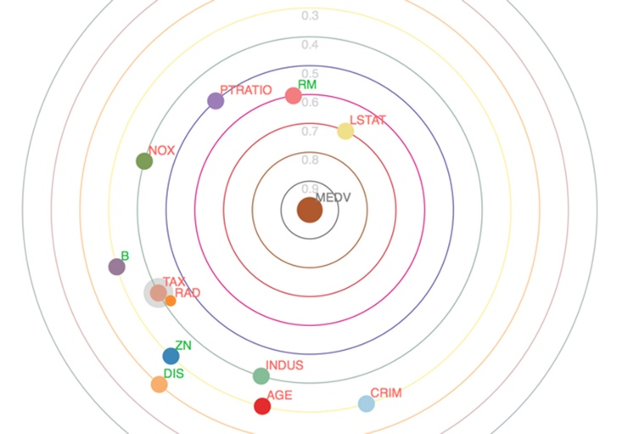

- For Alignment, either a Rose Chart or a Spiral Plot, or maybe even another Solar Correlation Map with the orbit representing alignment and the size of the node representing difference between scores.

